|  |  |
| --- | --- |
| **Estonian Embassy in Moscow**  5 Maly Kislovsky Pereulok  125 009 Moscow  Russian Federation  **Letter of invitation** | **Let´s do it! World foundation**  Rotermanni 8,  Tallinn 10111  Estonia  Registry code: 90010442  21st January 2013 |

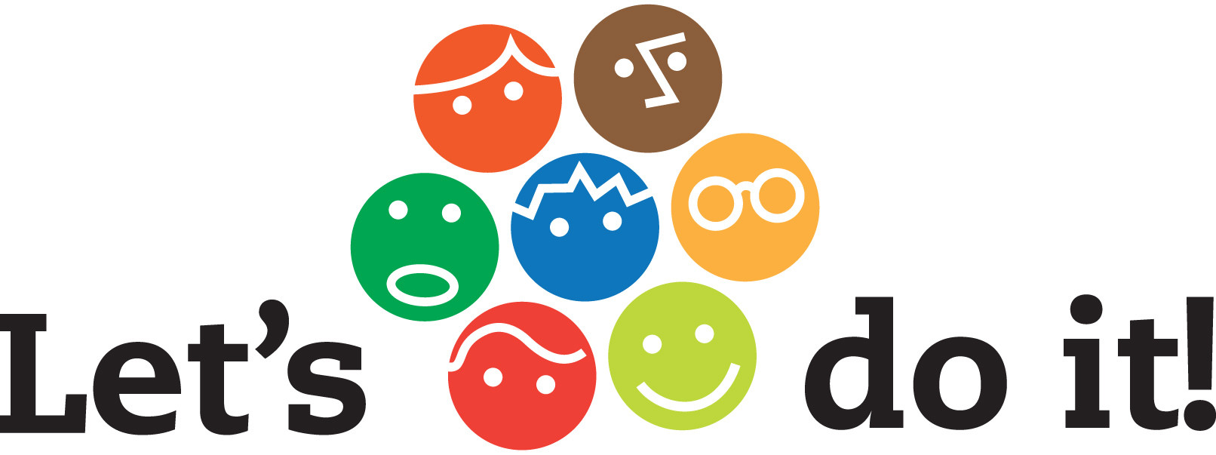

**To whom it may concern.**

We are cordially inviting **Miss Mari Mammukas,** born on 05.06.1983 (passport no. XXX – Russian origin), to participate at the *Let´s do it*! ***Clean World Conference 2013*** conference in Tallinn, Estonia, taking place between **1st – 3rd February 2013.**

This conference is a part of the global *Let’s do it! World* movement, which has the ambitious goal of cleaning the world from illegal trash. The purpose of the conference is to bring together like-minded people from 100 countries, to share ideas, knowledge and find solutions to different waste management issues. **Miss Mari Mammukas** has been invited to Estonia to represent Russia´s experience and knowledge in waste management.

During the conference between 1st - 3rd February 2013, she will be staying at Radisson Blu Hotel Olümpia, Liivalaia 33, Tallinn 10118, Estonia. ([radissonblu.com/olumpiahotel-tallinn](http://radissonblu.com/olumpiahotel-tallinn" \t "_blank))

**Miss Mari Mammukas** will arrange transportation to and from Tallinn, Estonia by herself. As the conference will start early in the morning February 1st, we have suggested to **Miss Mari Mammukas** to arrive already on 31st January. Financial responsibility for all accommodation, food and transportation expenses incurred by **Miss Mari Mammukas** during her stay in Estonia between 1st - 3rd February is the complete and total responsibility of the Let´s do it! World foundation.

Please feel free to contact me should you have any queries about the conference or invitee.

Yours sincerely,

**Eva Truuverk**

**Chairman of the board**

Let´s do it foundation

[eva@letsdoitworld.org](mailto:eva@letsdoitworld.org)

[www.letsdoitworld.org](http://www.letsdoitworld.org)

Tel: +372 552 6063